Project-Based Learning

Final Year Project

Session 2018-2022

Project submitted in partial fulfillment of the degree of

BS in Computer Science

Department of Computer Science

Faculty of Computer Science & Information Technology

Superior University, Lahore

FALL 2018

|  |  |  |  |  |  |
| --- | --- | --- | --- | --- | --- |
| Type (Nature of project) | | | [ ✓ ] **D**evelopment [ ] **R**esearch [✓] **R**&**D** | | |
| Area of specialization | | |  | | |
| FYP ID | | | FYP-BCSM-F21-072 | | |
| **Project Group Members** | | | | | |
| Sr.# | Reg. # | Student Name | | Email ID | *Signature |
| (i) | F18-221 | Bilal Akbar | | bcsm-f18-221@superior.edu.pk |  |
| (ii) | F18-208 | Usama Yaseen | | bcsm-f18-208@superior.edu.pk |  |
| (iii) |  |  | |  |  |

*The candidates confirm that the work submitted is their own and appropriate credit has been given where reference has been made to work of others

# Plagiarism Free Certificate

This is to certify that, I Muhammad Bilal Son of Muhammad Akbar, group leader of FYP under registration no FYP-BCSM—F21-072 at Computer Science Department, The Superior University, Lahore. I declare that my FYP report is checked by my supervisor.

Date:_____________  Name of Group Leader: M. Bilal Akbar Signature: _____________

Name of Supervisor: Muhammad Jameel Summra

Designation: Lecturer Designation: Associate Professor

Signature: ________________ Signature: _________________

HOD: Dr. Irfan U Din

Signature: _______________

**Project Report**

**Project Based Learning**

**Change Record**

|  |  |  |  |  |
| --- | --- | --- | --- | --- |
| **Author(s)** | **Version** | **Date** | **Notes** | **Supervisor’s Signature** |
| Usama Yaseen, Bilal Akbar | 1.0 |  |  |  |

**APPROVAL**

|  |  |
| --- | --- |
| **Project Supervisor** | |
| Comments: ___________________________________________________________________ | | |
| _____________________________________________________________________________ | | |
| Name: ______________________________ |  | |
| Date: _______________________________ | Signature: __________________________ | |

|  |  |
| --- | --- |
| **Project Manager** | |
| Comments: ___________________________________________________________________ | |
| _____________________________________________________________________________ | |
|  |  |
| Date: _______________________________ | Signature: __________________________ |

|  |  |
| --- | --- |
| **Head of the Department** | |
| Comments: ___________________________________________________________________ | |
| _____________________________________________________________________________ | |
|  |  |
| Date: _______________________________ | Signature: __________________________ |

# Dedication

*This work is dedicated to my Teachers, Parents and then most importantly to our university, who always support us in every phase of life and development.*

# Acknowledgments

I am grateful to the Almighty Allah, who blessed me with health, wisdom, knowledge, thoughts and opportunity to make some contribution in the form of present effort. I offer my humblest thanks from the deepest core of my heart to the Holy Prophet Muhammad (Peace be upon him), the most perfect and excelled among and ever born on the surface of earth.

I owe a great debt of gratitude to my supervisor, who has been really helpful throughout the project. Web Application work embodied in this dissertation was accomplished under the able guidance and affectionate supervision of **Sir Muhammad Jameel**, Professor at Superior University Lahore.

I am grateful to my teammate for working together as a true team and never making me feel alone during difficult times. Various parties have provided us with aid and guidance during the process of preparing and finishing this project. We may not have completed the job on time or at a higher standard if it hadn't been for these folks who were prepared to contribute their knowledge and time to assist me. As a result, in this part, we'd want to extend our heartfelt gratitude to all of the people who helped us.

# Executive Summary

Project Based System is a web application that is able to manage the students’ projects by computerized way. By manual tests/quizzes/exams we are wasting a lot of student’s time, papers and theoretical questions also don’t evaluate the perfect and accurate skills of a student, that is affecting the student skills and their own interests and not improving students’ capabilities against their skills. That’s why we proposed an “**Project Based Learning**” as its name describes its purpose. We are developing a system which is **project driven** system or it contain practical live solving questions but over main focus is to move our quiz/exam system into an implementation system based on coding questions. Through this system we can upload a project module question to each student and there will be no time has to be given to students to complete this project for final paper evaluation. Project consists of a single member.

# Table of Contents

Dedication v

Acknowledgements v

Executive Summary vi

Table of Contents vii

List of Figures **Error! Bookmark not defined.**

List of Tables **Error! Bookmark not defined.**

Chapter 1 13

Introduction 13

1.1. Background 14

1.2. Motivations and Challenges 14

1.3. Goals and Objectives 14

1.4. Literature Review/Existing Solutions 15

1.5. Gap Analysis 15

1.6. Proposed Solution 15

1.7. Project Plan 16

1.7.1. Work Breakdown Structure 16

1.7.2. Roles & Responsibility Matrix 17

1.7.3. Gantt Chart 18

1.8. Report Outline 19

Chapter 2 20

Software Requirement Specifications 20

2.1. Introduction 21

2.1.1. Purpose 21

2.1.2. Document Conventions 21

2.1.3. Intended Audience and Reading Suggestions 21

2.1.4. Product Scope 21

2.1.5. References 22

2.2. Overall Description 22

2.2.1. Product Perspective 22

2.2.2. Product Functions 23

2.2.3. User Classes and Characteristics 23

2.2.4. Operating Environment 23

2.2.5. Design and Implementation Constraints 24

2.2.6. User Documentation 24

2.2.7. Assumptions and Dependencies 25

2.3. External Interface Requirements 26

2.3.1. User Interfaces 26

2.3.2. Hardware Interfaces 26

2.3.3. Software Interfaces 2

2.3.4. Communications Interfaces 2

2.4. System Features 2

2.4.1. System Feature 1 2

2.4.1.1. Description and Priority 3

2.4.1.2. Stimulus/Response Sequences 3

2.4.1.3. Functional Requirements 3

2.4.2. System Feature 2 4

2.4.2.1. Description and Priority 4

2.4.2.2. Stimulus/Response Sequences 4

2.4.2.3. Functional Requirements 4

2.4.3. System Feature 3 (and so on) 4

2.5. Other Nonfunctional Requirements 5

2.5.1. Performance Requirements 5

2.5.2. Safety Requirements 5

2.5.3. Security Requirements 5

2.5.4. Software Quality Attributes 5

2.5.5. Business Rules 5

2.6. Other Requirements 6

Chapter 3 6

Use Case Analysis 6

3.1. Use Case Model 7

3.2. Use Case Descriptions 7

Chapter 4 8

System Design 8

4.1. Architecture Diagram 9

4.2. Domain Model 9

4.3. Entity Relationship Diagram with data dictionary 9

4.4. Class Diagram 10

4.5. Sequence / Collaboration Diagram 10

4.6. Operation contracts 10

4.7. Activity Diagram 11

4.8. State Transition Diagram 11

4.9. Component Diagram 11

4.10. Deployment Diagram 12

4.11. Data Flow diagram [only if structured approach is used - Level 0 and 1] 12

Chapter 5 13

Implementation 13

5.1. Important Flow Control/Pseudo codes 14

5.2. Components, Libraries, Web Services and stubs 14

5.3. Deployment Environment 14

5.4. Tools and Techniques 15

5.5. Best Practices / Coding Standards 15

5.6. Version Control 15

Chapter 6 16

Testing and Evaluation 16

6.1. Use Case Testing 17

6.2. Equivalence partitioning 17

6.3. Boundary value analysis 17

6.4. Data flow testing 17

6.5. Unit testing 18

6.6. Integration testing 18

6.7. Performance testing 18

6.8. Stress Testing 18

Chapter 7 19

Summary, Conclusion and Future Enhancements 19

7.1. Project Summary 20

7.2. Achievements and Improvements 20

7.3. Critical Review 20

7.4. Lessons Learnt 20

7.5. Future Enhancements/Recommendations 21

Appendices 22

Appendix A: User Manual 23

Appendix B: Administrator Manual 24

Appendix C: Information / Promotional Material 25

Reference and Bibliography 28

Index 30

# 

# List of Figures

1.1 Caption of first figure of first chapter 6

1.2 Caption of second figure of first chapter 7

2.1 Caption of first figure of second chapter 14

2.2 Caption of second figure of second chapter 22

2.3 Caption of third figure of second chapter 26

5.1 Caption of first figure of fifth chapter 49

5.2 Caption of second figure of fifth chapter 49

# List of Tables

1.1 label of first table of first chapter 6

1.2 label of second table of first chapter 7

2.1 label of first table of second chapter 14

2.2 label of second table of second chapter 22

2.3 label of third table of second chapter 26

5.1 label of first table of fifth chapter 49

5.2 label of second table of fifth chapter 49

# Chapter 1

# Introduction

**Chapter 1:** Introduction

In this chapter we are going to describe the purpose of Project based System. We are developing a system which is project driven system or it may contains subjective. Through this system we upload a project and time has to be given to students to complete this project for final paper evaluation. Project consists on a single member.

Project contains all modules of the current semester. When student complete his/ her project it gets evaluated on the basis of this project.

## Background

The background of the system is explained the past execution of the system as well as the existing system of the exam. To give the exam in the governmental institution such as in the school and university as well as in the non-governmental colleges, it is difficult to manage the examinee (students). But the governmental as well as the non-governmental institutions still it gives the exam in the form of manually (paper based). This kind of exam is affecting the organization economy and student skills in terms of money, the power of employee, the time to give the exam for the student and un relevant paper for the student that is not relevant to the actual market.

The proposed system is created the exam is given for the examinee/ student in project based and project-based learning system. So, this new created system is solving the existing problem easily and giving functionality of compiler to submit their task.

## Motivations and Challenges

While doing this system the team members has faced different challenges. But by the cooperation of all the group members and the advisor the team is now able to reach to the final result. i.e., all the group members strongly fight this challenge and take the turn to the front.

## Goals and Objectives

The general objective of this project is to develop the manual existing system of the student exam to the online project-based system.

We can save a lot of time and wastage of paper and by through this project we can also be able to make sure about the student skills and the comparison of student skills.

Organization significance

* It helps to get simple service to update the exam.
* It helps to control the time of the examinee and stop the exam automatically
* It helps to get better security of data.
* It helps to minimizing wastage of time.
* Its helps to save wastage of time.

## Literature Review/Existing Solutions

**Appendix project based system**

**Reference :**

1. Software Requirements Specification for project iTest, 2008.
2. Specification for Problem Based Learning Module, Souman Mandal, 2010.
3. Software Design Specification (SDS) Acropolis Course Management System, 2011
4. IEEE Recommended Practice for Software Requirements Specifications, Software Engineering Standards Committee of the IEEE Computer Society. 1998
5. Software Requirements Specification for PPDP Contact Management System (CMS)
6. Software Requirement Specifications, Project based nation system.

## Gap Analysis

All the data is important, so every answer your students give to your exams is tracked and recorded, giving you a clear view of their strengths and weaknesses.

## Proposed Solution

Student can learn a lot of things by project-based learning and to reduce the usage of paper and manual effort of writing and checking the paper, we are proposing Online System. Through this system we can save the human effort and time. Using Online System, teacher will upload the project / subjective that contains time to complete. Time duration depends on the functionality of the student project/ question. Project will contain all modules of ongoing semester. Student has to follow the instruction of the desired project. Project submission should contain project deployment picture. Evaluator will evaluate the project easily by checking the deployment and examiner will mark according to implemented functionality of the student project.

## Project Plan

We proposed a “**Project Based Learning**” as its name describes its purpose. We are developing a system which is **project driven** system or it may contain **subjective** but our main focus is to move our exams system into an implementation system based on coding questions. Through this system we can upload a project modules and time has to be given to students to complete this project for final paper evaluation. Project consists on a single member. Project contains all modules of the current semester.

We are planning a quick deployment of this project to our education systems to improve or education institution and making it better for the students who wanted to make their skills valuable and want to sell their skills to the needy persons and to make our country proud.

## Work Breakdown Structure

1. **Project Management** 
   1. Requirement gathering.
   2. Roles & Responsibility for group members.
2. **Reports / Documentation**
   1. Final Documentation Introduction
   2. Requirements Analysis
   3. System Design
   4. Implementation
   5. Testing & Performance Evaluation
   6. Conclusion
   7. End User Documentation
   8. Application Administration Documentation
   9. System Administrator Documentation
3. **System**
   1. Development Environment
      1. IDE: PyCharm and VS code
      2. Version Control
      3. Server: Django Server for development
      4. Redis/ Threading
      5. Database: SQLite as development purpose
         * 1. MySQL database for deployment
   2. Presentation Layer
   3. Business Logic Layer
   4. Data Management Layer
   5. Physical Layer

## Roles & Responsibility Matrix

|  |  |  |  |  |  |
| --- | --- | --- | --- | --- | --- |
| 1. **WBS** | **WBS Deliverable** | **Activity** | **Activity to Complete the Deliverable** | **Duration**  **(# of Days)** | **Responsible Team Member(s) & Role(s)** |
| **Project Management** | Requirement gathering | 1 |  | 2month | grouped |
| Presentation Layer | Designing | 2 |  | 1month | Usama Yaseen |
| Presentation Layer | Front-end Work | 3 |  | 1month | Usama Yaseen |
| Business Logic Lay. | Databases Design | 4 |  | 1month | Muhammad Bilal |
| Business Logic Lay. | Backend Api’s | 5 |  | 1month | Muhammad Bilal |
| Implementation Layer | Api’s Implementation | 6 |  | 1 month | Muhammad Bilal |
| Testing Phase | Testing &Deployment | 7 |  | 1 month | All Members / Tutors |

## Roles & Responsibility Matrix

## Report Outline

Developing a project-based system for the students who want to learn something and want to work with the side by side of market projects and tools.

This system can change their life’s by working with market is always a dream of every programming student.

# Chapter 2

# Software Requirement Specifications

**Chapter 2:** Software Requirement Specifications



## Introduction

## Purpose

The purpose of the system it provides system administer institution department and student with in central location for organizing several events. The purposes of this system provide the following reason: -

* No physical presence needed for examination.
* No wastage of time during evaluation.
* No wastage of paper.

## Document Conventions

< Describe the document convention that the document is intended for, such as developers, project managers, marketing staff, users, testers, and documentation writers. Describe what the rest of this SRS contains and how it is organized. Suggest a sequence for reading the document, beginning with the overview sections and proceeding through the sections that are most pertinent to each reader type.>

## Intended Audience and Reading Suggestions

<Describe the different types of reader that the document is intended for, such as developers, project managers, marketing staff, users, testers, and documentation writers. Describe what the rest of this SRS contains and how it is organized. Suggest a sequence for reading the document, beginning with the overview sections and proceeding through the sections that are most pertinent to each reader type.>

## Product Scope

Project based system is designed for Educational Institutes (like schools, universities, training centers).

The system handles all the operations, and generates reports as soon as the teacher mark the exam/ questions, that includes name, mark, time spent to solve the exam.

The scope of this proposed system will be explained in terms of users (scope of the system users) and function (module).

* User Role/ Group Management
* Administrator
* Examiner
* Student

**Function scope**

* **Login module : -** Design to make the system secure through authentication and authorization.
* **Registration module : -** The examinee (student) must be register before inter into the exam webpage.
* **View module : -** The student views their own mark as soon as the evaluation is done from the tutor side.

## References

**Appendix**

* Software Requirements Specification for project iTest, 2008 Specification for Problem Based Learning Module, Souman Mandal, 2010.
* Software Design Specification (SDS) Acropolis Course Management System, 2011.
* IEEE Recommended Practice for Software Requirements Specifications, Software Engineering Standards Committee of the IEEE Computer Society, 1998.
* Software Requirements Specification for PPDP Contact Management System (CMS).
* Software Requirement Specifications, Project based nation system.

## Overall Description

## Product Perspective

The package was design in such a way that future modifications can be done easily. The following conclusions can be deduced from the development of the project.

* It provides a friendly graphical user interface which proves to be better when compared to the existing system.
* Automation of the entire system improves the efficiency.
* It gives appropriate access to the authorized users depending on their permissions.
* It effectively overcomes the delay in communications.
* Updating of information becomes so easier.
* System security, data security and reliability are the striking features.
* The System has adequate scope for modification in future if it is necessary.

## Product Functions

<Summarize the major functions the product must perform or must let the user perform. Details will be provided in Section 3, so only a high level summary (such as a bullet list) is needed here. Organize the functions to make them understandable to any reader of the SRS. A picture of the major groups of related requirements and how they relate, such as a top level data flow diagram or object class diagram, is often effective.>

## User Classes and Characteristics

<Identify the various user classes that you anticipate will use this product. User classes may be differentiated based on frequency of use, subset of product functions used, technical expertise, security or privilege levels, educational level, or experience. Describe the pertinent characteristics of each user class. Certain requirements may pertain only to certain user classes. Distinguish the most important user classes for this product from those who are less important to satisfy.>

## Operating Environment

To develop this system we used software and hardware operating environment.

* Will be easy to use
* Will be supported for any OS browser because of web app.

**Software Environment :**

To develop the system we use different types of software environments such as: OS, Notepad++, Chrome browser for running the program, because of chrome browser support all programming languages, CSS and HTML keywords and Microsoft Office for writting the proposal.

**Hardware Environment :**

The hardware part of the operating environment also necessary for the developing of the new examination system. From the hardware operating environment we listed, that we use in the development of the system. Such as:

* Secondary storage device (flash and CDs)
* Cup (processor)
* Hard Disk
* Memory

**Methodology :**

In order to achieve the objective of this project, data collection or data gathering methodology are used such as interview, observation and questioner. And also use design, implementation and testing methodology in order to satisfy the objective of this project.

## Design and Implementation Constraints

* Development Environment
* IDE: PyCharm and VS code
* Version Control : Git
* Server: Django Server for development
* Database: SQLite as development purpose
  + MySQL database for deployment
* Presentation Layer
* Business Logic Layer
* Data Management Layer
* Physical Layer

## User Documentation

**Administrator : -** The administrator collects all the results after successful completion of the examination and then sends to the registrar.

The features (work) that are available to the Administrator are:

* The administrator has the full-fledged rights over the OES.
* Can create/delete an account.
* Can view the accounts.
* Can change the password.
* Can hide any kind of features from the both of users.
* Insert/delete/edit the information of available on OES.
* Can access all the accounts of the faculty members/students.

**Examiner : -** The database is prepared & loaded into the software. Selection for examination can be done language wise by the examiner. The results will be displayed immediately after completion of the examination.

The features (work) that are available to the examiner are:

* Can view the different categories of Test conducted by users.
* Can change password.
* Can view student marks.
* Can view and modify Results.

**Student : -** The student will login to the software and take his examination. He can also check his previous examinations marks and his details. The student will get result immediately after the completion of the examination.

The features (work) that are available to the students are:

* Can view the different categories of Test available in their account.
* Can change password.
* Can view their marks.
* Can view the various reading material.
* Can view and modify its profile but can modify it to some limited range.

## Assumptions and Dependencies

These could include third-party or commercial components that you plan to use, issues around the development or operating environment, or constraints. The project could be affected if these assumptions are incorrect, are not shared, or change. Also identify any dependencies the project has on external factors, such as software components that you intend to reuse from another project, unless they are already documented elsewhere (for example, in the vision and scope document or the project plan)

## External Interface Requirements

## 

## User Interfaces

User can choose which exam they want to practice and after logging in to their account, should have the paid test as the untaken test in his/her account. After completing each test, they will have their result in a pop-up window detailing questions they failed and the passed once. When the mouse is taken to this failed question, the solution of the question will drop and when the mouse is taken out of the question the solution disappears (this is however subjected to change by the developer if there exist better options:

**Site Administrator :**

The website allows the administrator to perform the below mentioned functions:

* Add questions and accompanied solution.
* Manage registered members.
* Manage exams- set types of exams, fix time periods for each exam and manage results.
* Manage question/ answer, Admin can select a test module and add test related to it. He can set time duration for each question and bulk upload attachments with questions, if any.
* Able to post updates of current vacancies etc.

## Hardware Interfaces

The hardware part of the operating environment also necessary for the developing of the new examination systems. From the hardware operating interface, we listed above, we used in the developing of the system. Such as:

* Secondary storage device (flash and CDs)
* Cup(processor)
* Hard disk
* Memory

## Software Interfaces

Following interfaces that are used:

* **Operating System:**

We have chosen windows & IOS/ Android operating system for its best support and user-friendliness as it provides us quality user-interfaces.

* **Database:**

We use Python models to store our services provided to the customers and various records like payment and transactions record etc.

* **Python:**

We are using Python programming language to implement our Project Based Learning idea for its most interactive support as this language is one of the modern and popular language of this era.

## Communications Interfaces

**Browser:**

This project will run on all types of web browsers which support modern languages.

**Protocols:**

This will support **FTP**, **HTTP** etc. It will provide secure platform as Python is giving us most secure form for us to provide security to our customers using **CSRF**.

## System Features

<This template illustrates organizing the functional requirements for the product by system features, the major services provided by the product. You may prefer to organize this section by use case, mode of operation, user class, object class, functional hierarchy, or combinations of these, whatever makes the most logical sense for your product.>

## System Feature 1

<Don’t really say “System Feature 1.” State the feature name in just a few words.>

## Description and Priority

Examination have been a priority in education. It is mainly how teachers, universities, and governments monitor learning. Maintaining this method of monitoring will allow different institutes to know if they are effectively educating their students.

## Stimulus/Response Sequences

Everyone is happy and giving us a very good response. Project based nation system is a web-based examination system where examinations are given online. Either through the internet or intranet using computer system. The main goal of this project-based nation system is to effectively evaluate the student thoroughly through a totally automated system that not only reduce the required time, cost of paper and human effort but also obtain fast and accurate results.

## Functional Requirements

* **Candidate module: -** The candidate will logon to the software and take his examination. He can also check his previous examinations marks and his details. The candidate will get result immediately after the exams get evaluated by the tutor.
* **Examiner module: -** The database is prepared & loaded into the software. Selection for examination can be done language wise by the examiner. The results will be displayed immediately after completion of the examination.
* **Administrator module: -** The administrator collects all the results after successful completion of the examination and sends to the main authority as and when required.

REQ-SF1-1: CRUD management for all things as system or Superuser

## System Feature 2

<Don’t really say “System Feature 1.” State the feature name in just a few words.>

## Description and Priority

<Provide a short description of the feature and indicate whether it is of High, Medium, or Low priority. You could also include specific priority component ratings, such as benefit, penalty, cost, and risk (each rated on a relative scale from a low of 1 to a high of 9).>

## Stimulus/Response Sequences

<List the sequences of user actions and system responses that stimulate the behavior defined for this feature. These will correspond to the dialog elements associated with use cases.>

## Functional Requirements

<Itemize the detailed functional requirements associated with this feature. These are the software capabilities that must be present in order for the user to carry out the services provided by the feature, or to execute the use case. Include how the product should respond to anticipated error conditions or invalid inputs. Requirements should be concise, complete, unambiguous, verifiable, and necessary. Use “TBD” as a placeholder to indicate when necessary information is not yet available.>

<Each requirement should be uniquely identified with a sequence number or a meaningful tag of some kind.>

REQ-SF2-1:

REQ-SF2-2:

REQ-SF2-3:

## System Feature 3 (and so on)

## Other Nonfunctional Requirements

## Performance Requirements

We will use CACHE, **REDIS** Technologies for the improvement of system

* The system support use of multiple users at a time.
* The system calculates result after exam completion.

## Safety Requirements

Following are the reasons:

* We will use **key Cloak** for this purpose.
* The database may get collapse due to virus or operating system failure. Therefore, it is required to take the database backup.

## Security Requirements

For making more secure we will going to use **outh2** libs and other libraries to make our system more secure.

## Software Quality Attributes

* **Availability:** Our system will easy be accessible at any time.
* **Correctness:** To improve accuracy we are deploying online compiler in our system.
* **Maintainability:** Our system will easy be maintainable.
* **Usability:** We are providing best user experience to our user.

## Business Rules

E-business systems are a set of online technologies, equipment and tools that a business uses to conduct business via the Internet. These systems help a company connect with customers, process orders and manage information.

## Other Requirements

Nothing! Until Tutor or anyone else mention! In a good way!

# Chapter 3

# Use Case Analysis

**Chapter 3:** System Analysis

As Use cases add value because they help explain how the system should behave and in the process, they also help brainstorm what could go wrong. They provide a list of goals and this list can be used to establish the cost and complexity of the system.

## Use Case Model

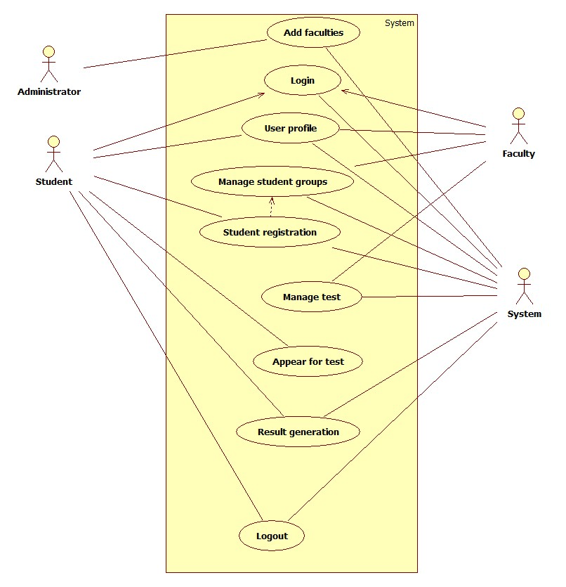

## 

## Use Case Descriptions

* Examiner will upload question or post a module requirement.
* Student will be able to see that requirement.
* Student can upload his working code using compiler.
* Checker can take the code or may run that code with his own pc.
* Can gave him the code error issues and can gave him revisions depending on the need.

# Chapter 4

# System Design

**System Design:**

We are using Django as system backend language and in that middleware handles responses and requests and then from views we send the response back to the front end.

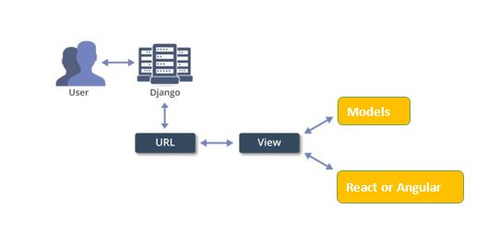

## Architecture Diagram



SuperAdmin

## Domain Model

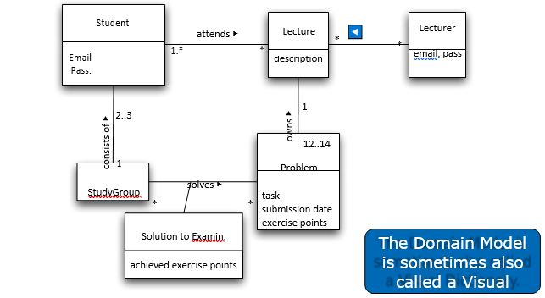

## Entity Relationship Diagram with data dictionary

1

M

M

M

M

M

M

M

1

M

**StudentExam**

**Result**

**Question**

**Has**

**Has**

**Creates**

**Exam**

**Add** to Cart

**Faculty**

**Student**

**Member**

## Class Diagram

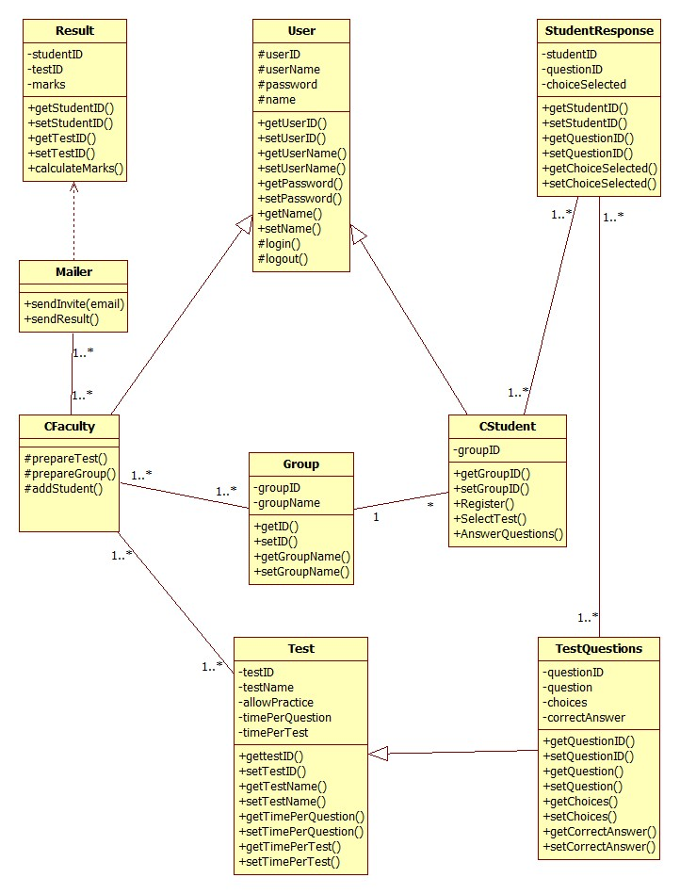

## Sequence / Collaboration Diagram

**Sequence Diagram Overview**

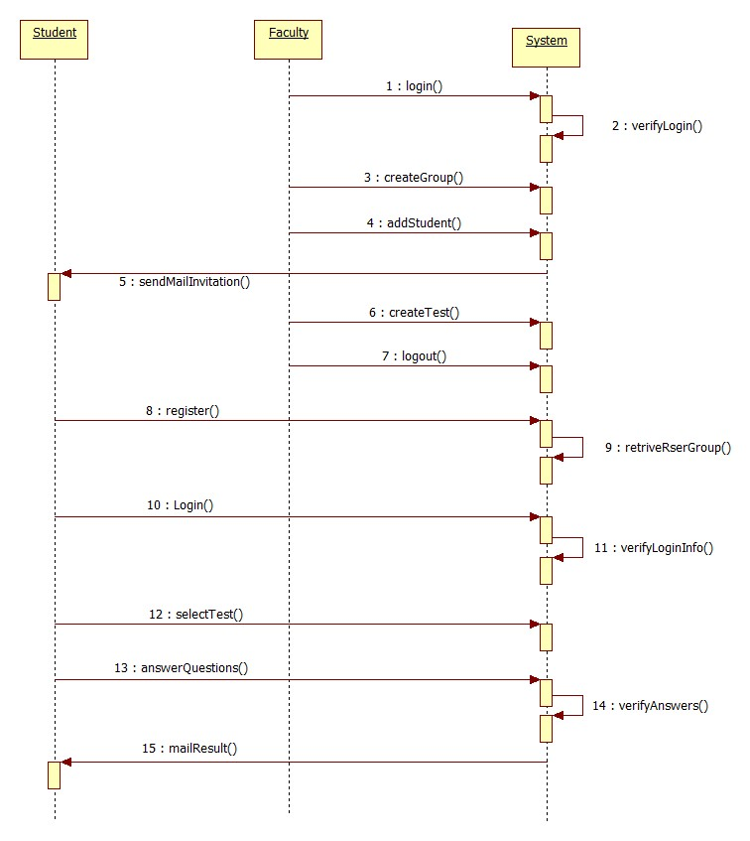

**Login Sequence Diagram**

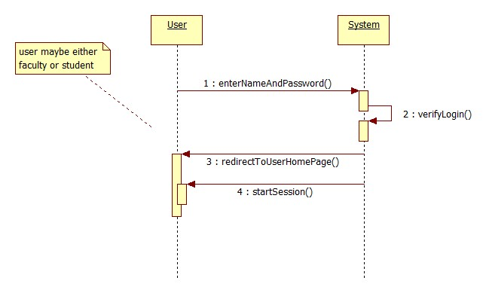

**Manage Student Sequence Diagram**

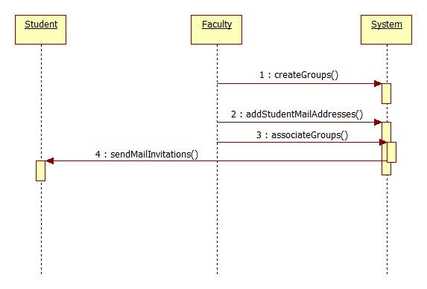

**Student Registration Sequence Diagram**

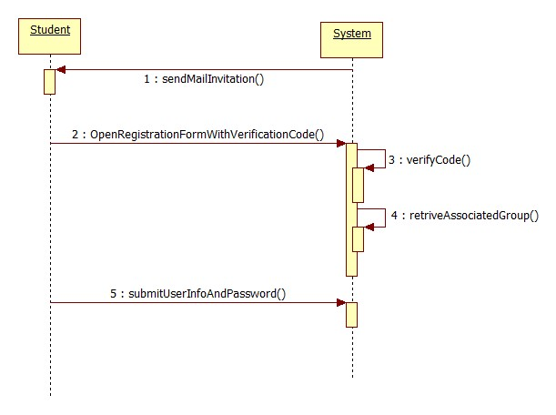

**Manage Test Sequence Diagram**

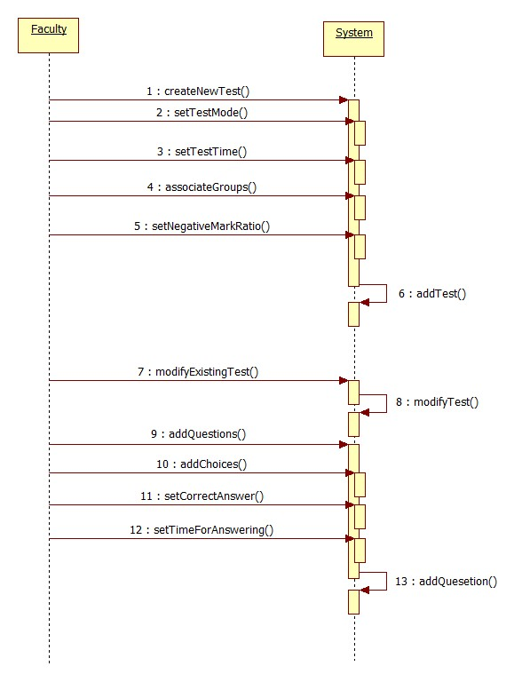

**Appear for Test Sequence Diagram**

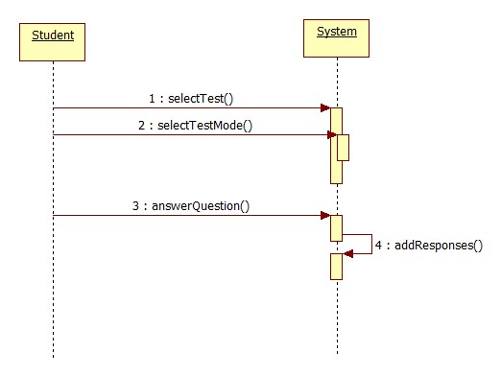

## Activity Diagram

**Login Activity Diagram**

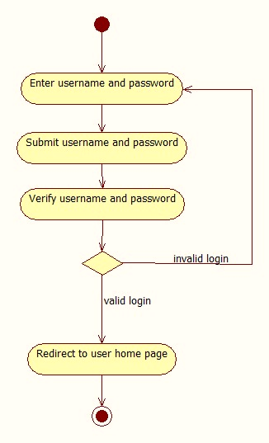

**Manage Students Activity Diagram**

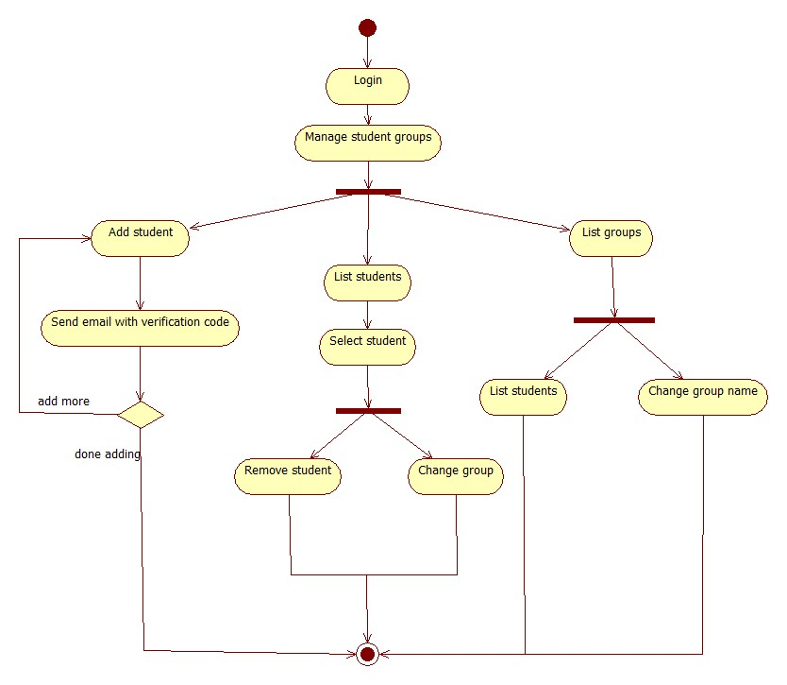

**Manage Tests Activity Diagram**

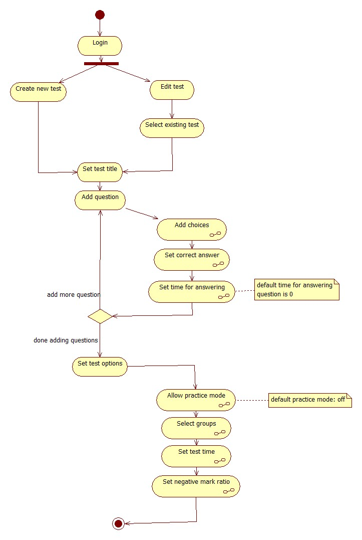

**Generate Result Activity Diagram**

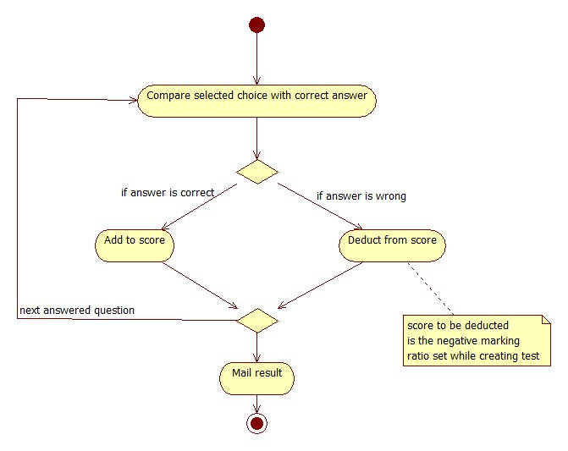

**Student Registration Activity Diagram**

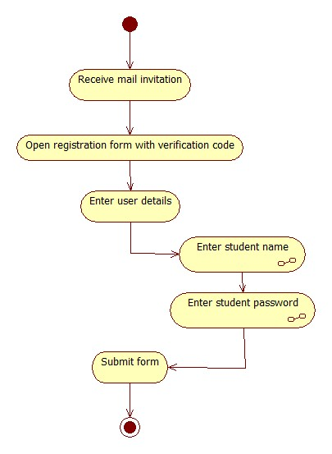

**Answer Test Activity Diagram**

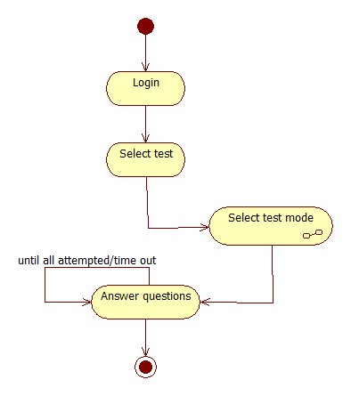

## State Transition Diagram

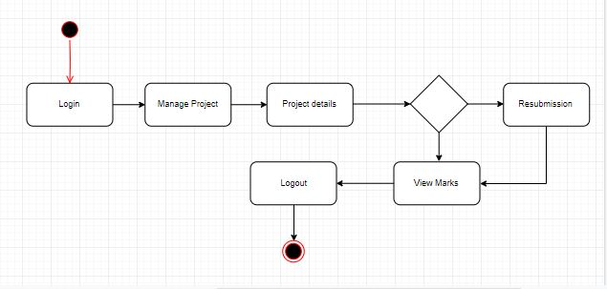

## Component Diagram

## Deployment Diagram

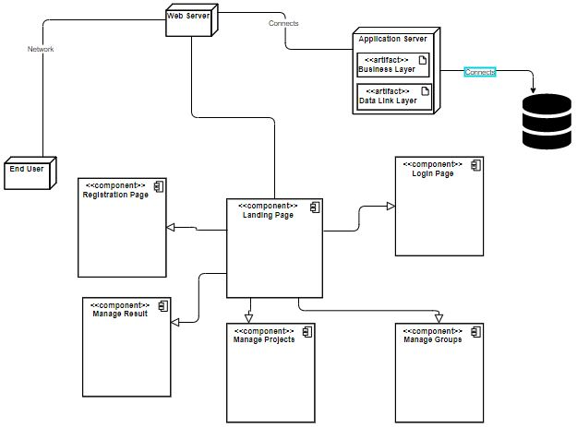

## Data Flow diagram

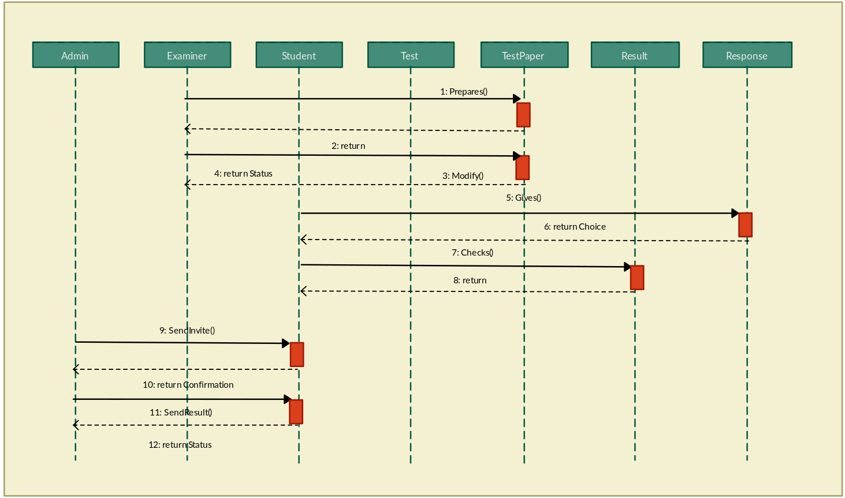

# Chapter 5

# Implementation

**Chapter 5:** Implementation

The implementation phase is where you and your project team member actually do the project work to produce the deliverables. The activities required to build each deliverable will be openly specified with in the project requirements document and project plan. Here they use proper deployment tools and coding standard according to their priority.

## Important Flow Control/Pseudo codes

* End user will open the website.
* It will login or register on it.
* If teacher then they will manage exam/ project, manage result and submit to admin.
* Teacher will give time to student to resubmit project.
* Admin will manage user and staff.
* End user can logout.

## Components, Libraries, Web Services and stubs

**Components:**

* Visual Studio Code
* PyCharm

**Web Services:**

* Rest Api’s and Restful Api’s

## Deployment Environment

Deployment environment will be web browser where user can access the web application to use it on any browser e.g: chrome, Microsoft Edge, Safari etc.

## Tools and Techniques

* Visual Studio Code
* PyCharm

**Technology:**

* **Front-End:** Html, CSS/ SCSS, Bootstrap
* Back-End API: Python Django and DRF
* Database: SQLite & MySQL

**Techniques:**

* Redis/ Threading
* Mautic for emails

## Best Practices / Coding Standards

It is highly recommended to use Python Django Framework coding standards when writing code.

* Python Style

If **else, loops** are somehow different from other languages.

* Import

Import libraries to use a **block of code** which is written for you in **Python.**

* Template Style

It use **jinja** templating style.

* View Style
* Model Style
* Classes

Classes name should follow the **Uppercase**/ **Camel Case** Convention.

* Packages and Modules

Packages and module name should be **lowercase**.

## Version Control

* Python provides us Django-versioning in Django framework which allows us to version the data stored in Django models, and stores only different, not content copy, which supports all field types excepts Many to Many (currently).
* Git

# Chapter 6

# Testing and Evaluation

**Chapter 6:** Testing and Evaluation

Software Testing is evaluation of the software/ system against requirements gathered from users and system specifications. Testing is conducted at the phase level in software development life cycle or at module level in program code depending on the approach model. While software evaluation is a type of assessment that seeks to determine if software or a combination of software programs is the best possible fit for the needs of a business/ client.

## Use Case Testing

Use case testing is a technique that helps to identify test cases that cover the entire system, on a transaction by transaction basis, from start to finish. It is a description of a particular use of the system at the end of user. It is used widely in developing tests or systems for acceptable levels.

## Equivalence partitioning

Equivalence partitioning which is also known as **Equivalence Class Partitioning**. In this method, the input domain data is divided into different equivalence data classes – which are generally termed as ‘Valid’ and ‘Invalid’. The inputs to the software or system are divided into groups that are expected to exhibit similar behavior.  Thus, it reduces the number of test cases to a finite list of testable test cases covering maximum possibilities.

## Boundary value analysis

It is a **Black-Box testing** technique used to check the errors at the boundaries of an input domain. The name comes from the boundary, which means the limits of an area. So, BVA mainly focuses on testing both valid and invalid input parameters for a given range of a software component.

The basic idea in normal boundary value testing is to select input variable values at their:

* Minimum
* Just above the minimum
* A nominal value
* Just below the maximum
* Maximum

## Data flow testing

This testing technique emphasize to cover all the data variables included in the program. It tests where the variables were declared and defined and where they were used or changed.

## Unit testing

While coding, the programmer performs some tests on that unit of program to know if it is error free. Testing is performed under white-box testing approach. Unit testing helps developers decide that individual units of the program are working as per requirement and are error free.

## Integration testing

Even if the units of software are working fine individually, there is a need to find out if the units if integrated together would also work without errors. For example, argument passing and data updating etc.

## Performance testing

This test proves how efficient the software is. It tests the effectiveness and average time taken by the software to do desired task. Performance testing is done by means of load testing and stress testing where the software is put under high user and data load under various environment conditions.

## Stress Testing

Stress testing verifies the stability and reliability of the system. This test particularly determines the system on its robustness and error handling under extremely heavy load conditions.

# Chapter 7

# Summary, Conclusion and Future Enhancements

**Chapter 7:** Summary, Conclusion & Future Enhancements

## Project Summary

[Paragraph Text 12 pt., Calibri, 1.5 Line Spacing, Justified]

## Achievements and Improvements

**Achievements:**

Following are the achievements till now:

* Requirements gathering is done.
* Project phases and plan is ready.
* 30% working prototype is ready.

**Improvements:**

We are up for any recommendation/ feedback from anyone to improve the system. We’ll also try to improve the system.

## Critical Review

## Lessons Learnt

## Future Enhancements/Recommendations

# Appendices

# Appendix A: User Manual

[Paragraph Text 12 pt., Calibri, 1.5 Line Spacing, Justified]

[*Between 4 to 8 lines describe what is this appendix all about*]

**Appendix A:** Appendix Title

**[Appendix Heading 1]: [20 pt., Calibri, Bold, Left aligned]**

Text in 12-Point Size, Times New Roman, 1.5 Line Spacing.

* 1. **First Level heading [16 pt., Calibri, Bold, Left aligned]**

[Paragraph Text 12 pt., Calibri, 1.5 Line Spacing, Justified]

* + 1. **Second level heading [14 pt., Calibri, Bold, Left aligned]**

[Paragraph Text 12 pt., Calibri, 1.5 Line Spacing, Justified]

* + - 1. **Third level heading [12 pt., Calibri, Bold, Left aligned]**

[Paragraph Text 12 pt., Calibri, 1.5 Line Spacing, Justified]

# Appendix B: Administrator Manual

[Paragraph Text 12 pt., Calibri, 1.5 Line Spacing, Justified]

[*Between 4 to 8 lines describe what is this appendix all about*]

* 1. **First Level heading [16 pt., Calibri, Bold, Left aligned]**

[Paragraph Text 12 pt., Calibri, 1.5 Line Spacing, Justified]

* + 1. **Second level heading [14 pt., Calibri, Bold, Left aligned]**

[Paragraph Text 12 pt., Calibri, 1.5 Line Spacing, Justified]

* + - 1. **Third level heading [12 pt., Calibri, Bold, Left aligned]**

[Paragraph Text 12 pt., Calibri, 1.5 Line Spacing, Justified]

# Appendix C: Information / Promotional Material

**All information used in the advancement of, or otherwise in linkage with, the Company  is referred to as promotional material, which contains artwork, advertising materials (regardless of medium), showcase components, packaging materials, brochures, posters, and internal and external signage.**

* 1. **Broacher**

A brochure is often folded and contains simply summary information with a promotional bent. A booklet is usually made up of numerous sheets of paper tied together using staples, string, or plastic binding. A single bit of unfolded paper, on the other hand, is commonly referred to as an insert, flyer, or bulletin.

* 1. **Flyer**

A flyer is basically a single, unfolded printing sheet used to promote an event, service, product, or concept. A flyer usually carries a short statement that may be easily understood.

* 1. **Standee**

A standee is a big self-contained exhibit that is used to promote brands, products, and events. They can range from self-standing posters to three-dimensional displays with moving elements and lighting. Because of their portability, they are a simple and appealing advertising strategy.

* 1. **Banner**

Banner ads are a common form of online marketing that are graphics rather than text-based. The goal of banner ads is to promote the product and/or to drive traffic to the company's website from the host website.

* 1. **First Level heading [16 pt., Calibri, Bold, Left aligned]**

[Paragraph Text 12 pt., Calibri, 1.5 Line Spacing, Justified]

* + 1. **Second level heading [14 pt., Calibri, Bold, Left aligned]**

[Paragraph Text 12 pt., Calibri, 1.5 Line Spacing, Justified]

* + - 1. **Third level heading [12 pt., Calibri, Bold, Left aligned]**

[Paragraph Text 12 pt., Calibri, 1.5 Line Spacing, Justified]

# Appendix [no.]: Appendix Title

[Paragraph Text 12 pt., Calibri, 1.5 Line Spacing, Justified]

[*Between 4 to 8 lines describe what is this chapter all about*]

* 1. **First Level heading [16 pt., Calibri, Bold, Left aligned]**

[Paragraph Text 12 pt., Calibri, 1.5 Line Spacing, Justified]

* + 1. **Second level heading [14 pt., Calibri, Bold, Left aligned]**

[Paragraph Text 12 pt., Calibri, 1.5 Line Spacing, Justified]

* + - 1. **Third level heading [12 pt., Calibri, Bold, Left aligned]**

[Paragraph Text 12 pt., Calibri, 1.5 Line Spacing, Justified]

# Reference and Bibliography

**Reference and Bibliography**

[1] Ana, P., & Bukie, P , Design and implementation of project basedination administration system for universities. Global Journal of Mathematical Sciences, 12(1), 39–51, (2013).

https://doi.org/10.4314/gjmas.v12i1.16

[2] https://www.tutorialspoint.com/software_engineering/software_testing_overview.htm

‌[3] https://www.qaoncloud.com/boundary-value-analysis-ecp-explained-with-examples/#:~:text=Boundary%20Value%20Analysis%20(BVA)%20is,range%20of%20a%20software%20component.

[4] https://stackoverflow.com/questions/16614368/software-testing-vs-software-evaluation

[5] https://www.scribd.com/doc/22746893/Online-Examination-Project-Report-Documentation-Only

# Index

**Index**

**[A]**

**[B]**

**[C]**